

Nebula Fashion Limited

CORPORATE OFFICE:
House – 5, Road – 28, Sector – 7, Uttara, Dhaka, Bangladesh.
Tel: (880) 2 8956063, Fax: (880) 2 8911562
Email: nebulafashion@yahoo.com

APPAREL MANUFACTURER & EXPORTER

From the desk of Managing Director:

Nebula Fashion Limited (NFL) is one of the privately owned companies engaged mainly in manufacturing and exporting knitted garments from Bangladesh. It has the combination of state-of-the-art manufacturing facilities at one of the prime industrial zones in Dhaka, Bangladesh. The product ranges are: gents/ladies undergarments, crew/v-neck t-shirt, vest, knit/woven boxer, sleepwear, pajama set, etc.

NFL plays a critical role in quality control for all its customers. It has able to establish quality control as a separate entity from sales and production. It believes there are two essential elements in quality control: leadership of management and careful inspection of merchandise. The main purpose of such belief in quality control is a long lasting NFL’s tradition to offer its buyers first-quality merchandise at all times. For these reasons it is continuously following a measurement based strategy that focuses on process improvement and variation reduction through the application of Six Sigma.

NFL also plays a major role in the economic development of the country. It actively recruits and employs skilled workers from the local community. It strictly follows the local labor law of the country in every steps of its recruitment process.

NFL follows a fair business practice at all levels. It is an equal opportunity employment organization.

Data Facts

- PHYSICAL ADDRESS OF THE FACTORY : “Nebula Tower” Plot-547
Gazirchot, DEPZ Road
Ashulia Industrial Zone
Savar, Dhaka.

- YEAR OF INCORPORATION : 2007

- LEGAL FORM OF THE COMPANY : PRIVATE LIMITED COMPANY

- PRODUCTION LINES : 5

5. PRODUCTION CAPACITY PER MONTH : 25,000 dozen of basic t-shirt or its
equivalent worth of assorted garments

6. ORIGIN OF MACHINERIES : Japan & China.

7. FACTORY COVERED AREA : 20,000 sq.ft.

8. BANK DETAILS : Prime Bank Limited
Gulshan Branch
Plot No.1, Road No.109, Block- CEN(H)
Gulshan Avenue,
Gulshan, Dhaka -1212
Bangladesh.
SWIFT: PRBLBDDHA016

- CATEGORY WISE NUMBER OF MACHINES:

SL.NO | Category | Number of Machines
1. | Plain Machine – Single Needle | 50
2. | Over Lock – 4 Thread | 24
3. | Flat Lock – 5 Thread | 16
4. | Bar tack | 4
5. | Back-tape Chain Stitch | 4
6. | Button Hole | 2
7. | Button Attach | 2
8. | Rib Cutting | 2
9. | Cutting Machine | 2
10. | Vacuum Table | 8
11. | Steam Iron | 8

- PRODUCT CATALOG:
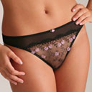
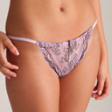
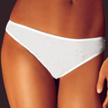
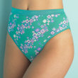
a) LADIES PANTY RANGE:

Bikini String Bikini Hi Cut Bikini (Basic)

b) CAMISOLE, VEST & BOXER RANGE:


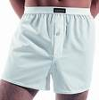

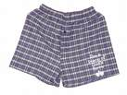

Ladies Camisole (Basic) Gent’s Vest (Basic) Boxer Woven Boxer

c) T-SHIRT RANGE:
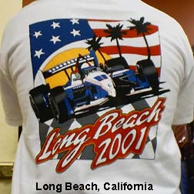
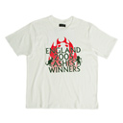
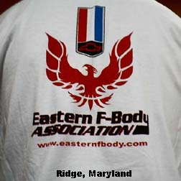
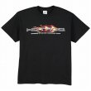

T-shirt (back view) T-shirt (backview) Basic T-shirt (White) Basic T-shirt (Black)

NEBULA FASHION LIMITED

CORPORATE OFFICE

NEBULA FASHION LIMITED
HOUSE-5, ROAD-28, SECTOR-7
UTTARA MODEL TOWN, UTTARA
DHAKA, BANGLADESH.

TELEPHONE: (880) 2 8956063.
FAX: (880) 2 8911562.

EMAIL: nebulafashion@yahoo.com

CORPORATE CONTACT LIST

- Abdul Ahad : Advisor
Mobile/Cell: 0171 172 1406

- Khawaja M Minnatullah : Chairman
Mobile/Cell: 0171 152 6589

3. Riyadh Zabir : Managing Director
Mobile/Cell: 0171 153 5360

4. Akhter Hussain : Director
Mobile/Cell: 0172 019 1525

